Christmas Joy!
The giving of gifts is not something man invented. God started the giving spree when He gave a gift beyond words, the unspeakable gift of His Son!
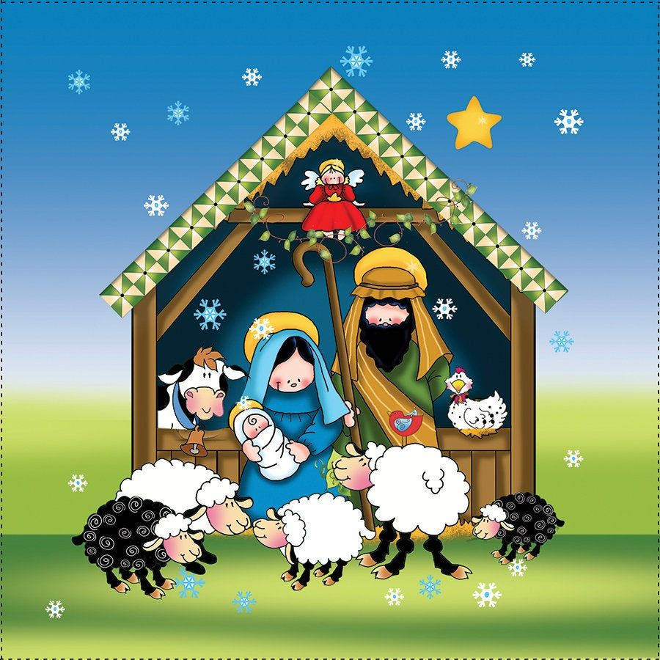

Our annual toy drive for children in Camden!
Bring donations to your classroom by December 4, 2025
Suggestions:
Pre-school: pre-school toys, rattles, infant toys
Kindergarten: building sets, Legos, mega-blocks
1st grade: dolls (ethnic), cars, trucks
2nd grade: dress-up outfits, costumes, princesses, superheroes, etc.
3rd grade: tea sets, kitchen sets, racetracks with cars
4th grade: card games, memory board games, Scrabble Junior, etc.
5th grade: brain teasers, books (for boys or girls)
6th grade: art kits, science kits, STEM projects for kids
7th grade: board games, water bottle decorations,
8th grade: sports equip. - basketballs, footballs, soccer balls, etc.

As always, we are grateful for any toy donations you can make but no toy guns or weapon toys of any kind.

Toys will be donated to Sacred Heart Parish, Camden.
THANK YOU!

