**2020 Gala Auction Class Project - KA**

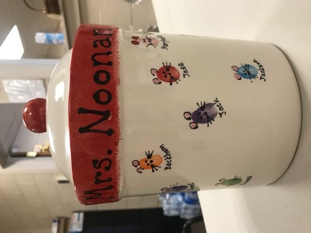 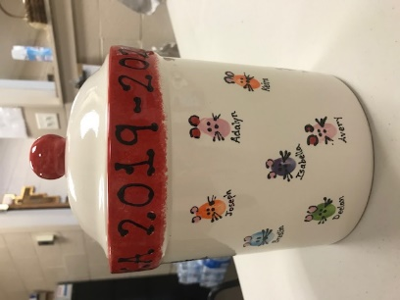

A family Cookie Jar with student fingerprints as mice. All fingerprints are labeled with student names. Mrs. Noonan includes a Noonan Family favorite cookie recipe.

**Starting Bid $100**

Bidder’s Name (First/Last) ________________________

Email _________________________________________

Phone Number _________________________________

I am submitting my bid of $ _______________

**Bidding Guidelines:**

* Complete the form above including your best bid for your child’s classroom project. You will **not** be contacted if you are out bid by another party.
* Bids should be submitted to the Advancement Office **no later than March 25th.**
* Bids will be compiled, and the top bid submitted for each project will be **contacted as the winning party by March 29th**.
* The party with the winning bid must submit payment and collect their Classroom Project **by March 31st**.
* Payment will be accepted in the form of cash or check payable to St. Margaret Regional School.

**2020 Gala Auction Class Project – KB**

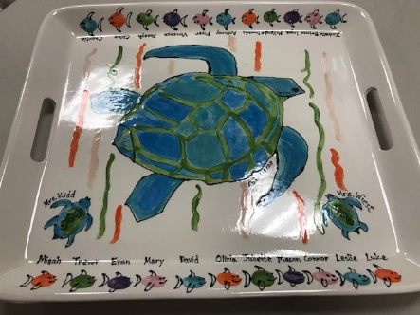

Serving Platter with student fingerprints as fish. All fingerprints are labeled with student names. This colorful tray is the last Classroom Project memory of Mrs. Kidd’s time at SMRS.

**Starting Bid $125**

Bidder’s Name (First/Last) ________________________

Email _________________________________________

Phone Number _________________________________

I am submitting my bid of $ _______________

**Bidding Guidelines:**

* Complete the form above including your best bid for your child’s classroom project. You will **not** be contacted if you are out bid by another party.
* Bids should be submitted to the Advancement Office **no later than March 25th.**
* Bids will be compiled, and the top bid submitted for each project will be **contacted as the winning party by March 29th**.
* The party with the winning bid must submit payment and collect their Classroom Project **by March 31st**.
* Payment will be accepted in the form of cash or check payable to St. Margaret Regional School.

**2020 Gala Auction Class Project – 2A**

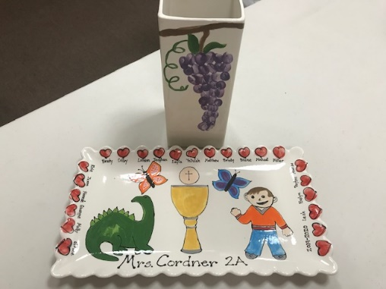

Dinosaurs, First Holy Communion, and Flat Stanley…. This serving platter and wine decanters should not be missed. Student fingerprints are displayed in the shape of hearts. All fingerprints are labeled with student names.

**Starting Bid $130**

Bidder’s Name (First/Last) ________________________

Email _________________________________________

Phone Number _________________________________

I am submitting my bid of $ _______________

**Bidding Guidelines:**

* Complete the form above including your best bid for your child’s classroom project. You will **not** be contacted if you are out bid by another party.
* Bids should be submitted to the Advancement Office **no later than March 25th.**
* Bids will be compiled, and the top bid submitted for each project will be **contacted as the winning party by March 29th**.
* The party with the winning bid must submit payment and collect their Classroom Project **by March 31st**.
* Payment will be accepted in the form of cash or check payable to St. Margaret Regional School.

**2020 Gala Auction Class Project – 2B**

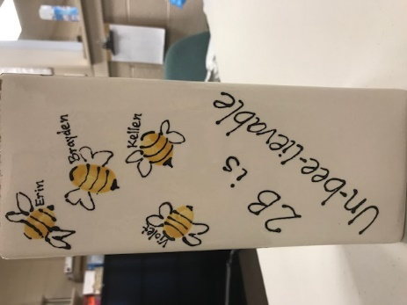 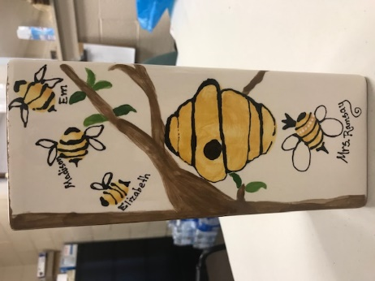

Un-bee-lievable! This flower vase displays student fingerprints are in the shape of cute bumble bees. All fingerprints are labeled with student names.

**Starting Bid $100**

Bidder’s Name (First/Last) ________________________

Email _________________________________________

Phone Number _________________________________

I am submitting my bid of $ _______________

**Bidding Guidelines:**

* Complete the form above including your best bid for your child’s classroom project. You will **not** be contacted if you are out bid by another party.
* Bids should be submitted to the Advancement Office **no later than March 25th.**
* Bids will be compiled, and the top bid submitted for each project will be **contacted as the winning party by March 29th**.
* The party with the winning bid must submit payment and collect their Classroom Project **by March 31st**.
* Payment will be accepted in the form of cash or check payable to St. Margaret Regional School.

**2020 Gala Auction Class Project – PK4 Chambers**

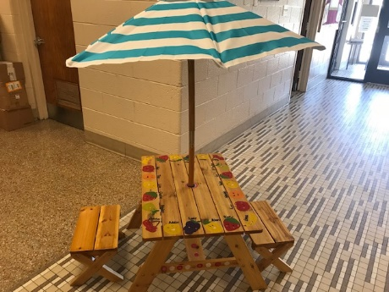

A picnic for two! This shaded table, suitable for outside, displays student fingerprints as pieces of fruit. Fingerprints are labeled with student names.

**Starting Bid $130**

Bidder’s Name (First/Last) ________________________

Email _________________________________________

Phone Number _________________________________

I am submitting my bid of $ _______________

**Bidding Guidelines:**

* Complete the form above including your best bid for your child’s classroom project. You will **not** be contacted if you are out bid by another party.
* Bids should be submitted to the Advancement Office **no later than March 25th.**
* Bids will be compiled, and the top bid submitted for each project will be **contacted as the winning party by March 29th**.
* The party with the winning bid must submit payment and collect their Classroom Project **by March 31st**.
* Payment will be accepted in the form of cash or check payable to St. Margaret Regional School.

**2020 Gala Auction Class Project – PK4 Robinson**

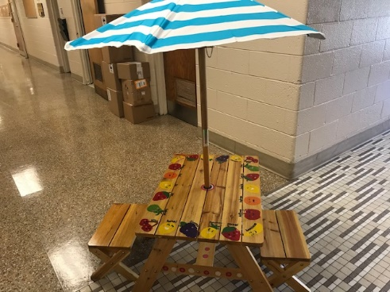

A picnic for two! This shaded table, suitable for outside, displays student fingerprints as pieces of fruit. Fingerprints are labeled with student names.

**Starting Bid $130**

Bidder’s Name (First/Last) ________________________

Email _________________________________________

Phone Number _________________________________

I am submitting my bid of $ _______________

**Bidding Guidelines:**

* Complete the form above including your best bid for your child’s classroom project. You will **not** be contacted if you are out bid by another party.
* Bids should be submitted to the Advancement Office **no later than March 25th.**
* Bids will be compiled, and the top bid submitted for each project will be **contacted as the winning party by March 29th**.
* The party with the winning bid must submit payment and collect their Classroom Project **by March 31st**.
* Payment will be accepted in the form of cash or check payable to St. Margaret Regional School.